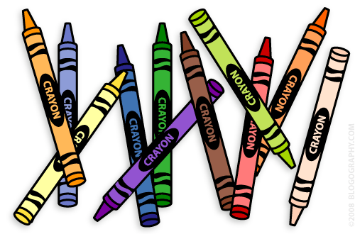
Our 1st Grade Classroom News
The Week of August 8th – 12th

Email: Lweeks@bluevalleyk12.org Website: www.bluevalleyk12.org/hes/lweeks

- I will update you with important information in this section every week.

- Students can bring a water bottle to school that has a secure lid that will prevent spilling.
- Students can bring their own snack to school every day.

Important Info

August 9th School Supply Drop-off 4:30pm – 6pm

August 10th Meet the Teaccher Night
4:45 – 5:15pm

August 11th First Day of School

Upcoming Events
I will provide an app and website of the week in this section. This is just to help any parent that wants more information on what they can be doing with their child technology wise at home. These are just suggestions and will never be required. These suggestions are from me and not the district.
Tech of the Week

In this section, I will list 3 challenges of the week. These challenges will relate to reading, writing, and math. Each challenge will be based on exactly what was taught in that subject area that week so you are aware of what we are learning in each subject. The students will be required to pick at least ONE of the challenges to complete by the following Friday. They will complete these challenges in their homework notebook that will be sent home on August 19th. I will explain this more during Meet the Teacher night. This will be their only required homework other than completing a reading log starting in September.

Challenges of the Week

